Vancouver
#YVR1&2 – 450 Derwent PL Delta, British Columbia V3M 5Y9
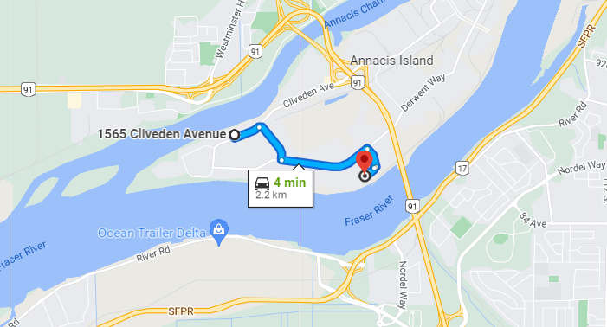

#YVR3 – 109 Braid St., New Westminster, British Columbia V3L 3R9
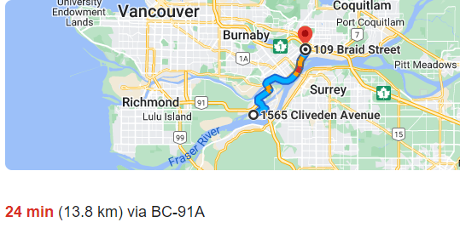

#YVR4 – 4189 Salish Sea Way, Tsawwassen (Delta), British Columbia V4M 0B9
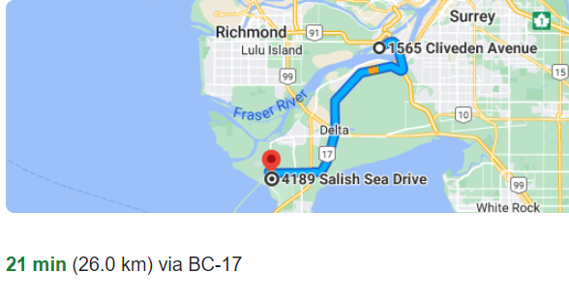

Calgary
#YYC1 – 293069 Colonel Robertson Way and Crossiron Blvd, Balzac, Alberta T4A 1C6
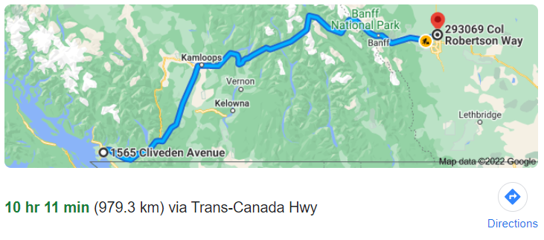

Edmonton
#YEG1 – 1440 39 Ave, Nisku, Leduc County, AB T6W 1A7
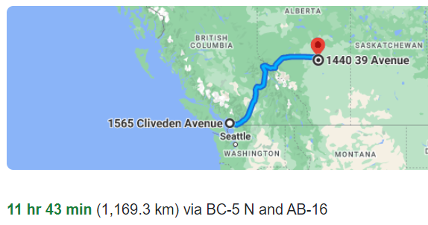

Toronto
#YYZ1 – 6363 Millcreek Drive Mississauga, Ontario L5N 1L8
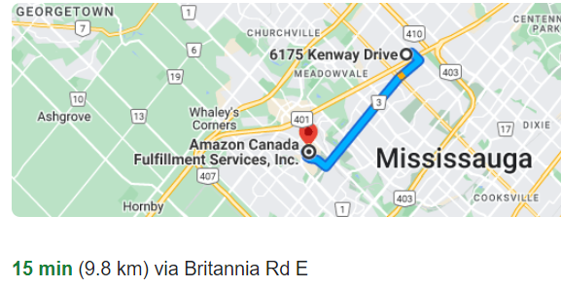

#YYZ2 – 2750 Peddie Rd. Milton, Ontario L9T 6Y9
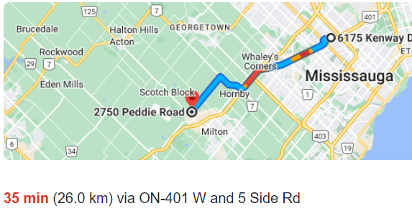

#YYZ3 – 7995 Winston Churchill Blvd. Brampton, Ontario L6Y 0B2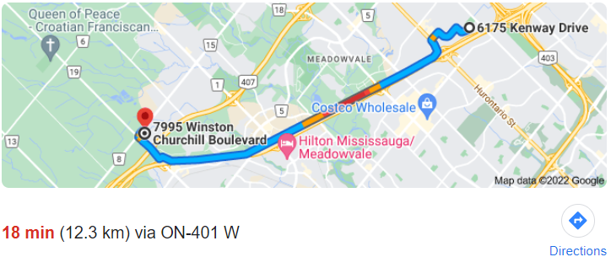

#YYZ4/#YYZ6 – 8050 Heritage Rd., Brampton, Ontario L6Y 0C9
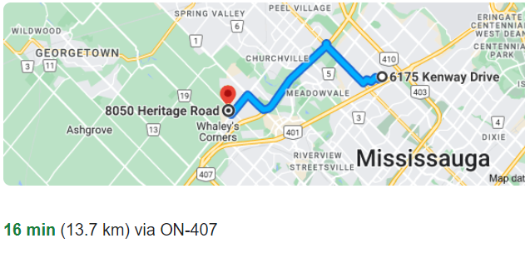

#YYZ7 – 12724 Coleraine Dr., Caledon (Bolton), Ontario L7E 4L8
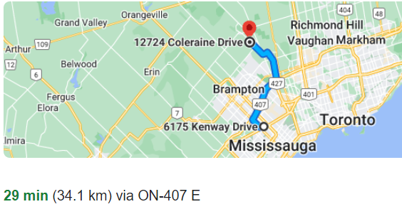

#PRTO – 6110 Cantay Rd. Mississauga, Ontario L5R 3W
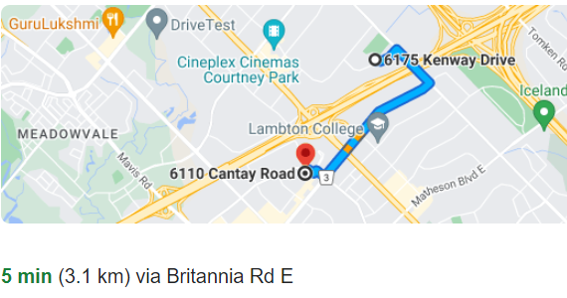

#YYZ9 – 900 Passmore Ave, Scarborough Ontario
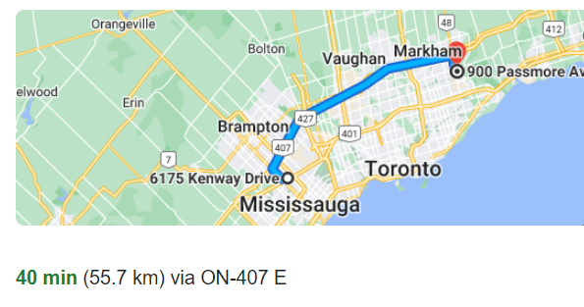

#YOO1 – 789 Salem Road N., Ajax ON L1Z 0J2
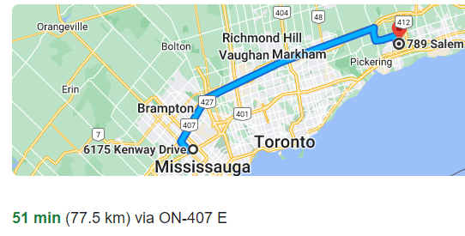

#YHM1 – 110 Aeropark Blvd., Mount Hope, ON L0R 1W0
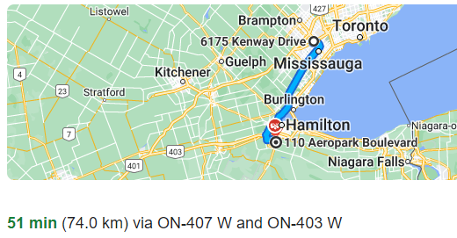

Ottawa
#YOW1 – 5225 Boundary Road, Ottawa, Ontario, Canada K4N 1P6
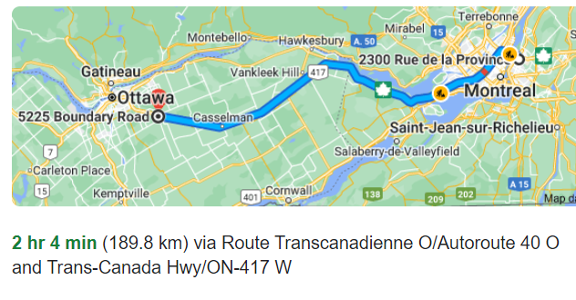

Montreal
#YUL2 – 3000 Rue Louis-A-Amos, Montréal (Lachine) – Waze
